List of tables
List of Abbreviation
Introduction
Background
Problem Statement
Proposed solution
Aim and Objective
Scope
Intellectual challenge
Rationale
Contribution
Structure of Thesis
Chapter-2 Project Plan…
Gantt chart- semester 1, Semester 2…
Risk Analysis…
Workflow-diagram
Chapter-3 Literature Review…
Overview Background..
Review Of existing project…

Abstract
The academic world of the present day is quite dynamic, and students are likely to struggle with their ability to follow a regular study routine, plan the effective study time, and assess their knowledge of the study resources. To fix these problems, a proposed solution will be Study Mate, which is an AI-driven mobile app that will serve as a personal study assistant. The system uses the principles of artificial intelligence and adaptive learning to provide individual quizzes, custom-made study plans, and automatically monitor academic progress.
Study Mate is focused on the basic functionality of an AI quiz generator that uses a custom Natural Language Processing (NLP) model to interpret study resources that are inputted by the users and creates questions regarding the topic user gives. According to the results of the quiz, an adaptive study planner modifies the learning schedule, working on the weak points and better using the study time. Moreover, the app also includes automated goal tracking and intelligent reminders, allowing users to track their progress and be motivated without having to work on it manually.
The suggested architecture includes a cross-platform frontend based on Flutter, a backend API management system based on Spring boot, and a custom NLP model with the use of Firebase Cloud Messaging (FCM): notifications. This combination is the guarantee of the smooth user experience, effective data analysis, and smart learning support. In the end, Study Mate will contribute to improved learning results and serve the purpose of assisting students in achieving self-discipline and lifelong learning improvement by a personalized, data-driven, and interactive learning experience.

Introduction
In the modern busy academic world students often have a hard time keeping up with their studying habits, learning to have time and to understand what exactly they should improve on. Most learners spend most of their time studying but they cannot attain desired outcomes mostly because their study practice is not consistent with their own learning patterns. These issues emphasize the necessity of more intelligent and responsive learning support applications that can be used to help students arrange and streamline the study processes.
To mitigate this issue, a new project will be suggested that gives rise to Study Mate, an AI-assisted mobile app that can improve the process of planning, tracking, and assessing the learning of the student. Inspired by the current developments in the fields of artificial intelligence and individualized learning systems, the project will focus on the possibility of using intelligent technologies to improve the efficiency of students in studying and to provide them with a deeper understanding of their progress in the field of studies. The combination of dynamic decision-making and artificial support will help Study Mate to provide a more organized, supportive, and responsive study experience to learners.
The general purpose of this project is to help make better the study discipline and learning results through creating a solution that is easy, realistic, and based on the real student requirements.
Problem Statement
The modern students may not have the ability to study regularly and define the spheres of education that students should learn more. Even with the long-term hours spent in the study, several learners cannot attain effective results, due to the lack of coordination between the study practices and their personal learning patterns. The academic performance is also influenced by poor study habits, irregular schedules, and poor self-regulation (Dagoc & Orlanda, 2024; Poudel, 2023). All these complications are further enhanced by the fact that the students have a hard time keeping up with their progress in learning and effective time management in their studies.
Current tools in study e.g. simple to-do list or fixed planners are manual and not based on the performance of a learner and his changing needs. Hariyanto et al. (2025) note that the conventional study system is not intelligent and does not provide a system that personalizes the learning process, which usually leads to poor time management and low academic performance. In a similar way, Gupta et al. (2024) state that the adaptive and AI-powered learning systems must be provided to provide individualized guidance, focused practice, and performance-related feedback.
To overcome these shortcomings, the solution has been proposed as the Study Mate, which is an AI-powered adaptive study assistant. The system is meant to address the issues of the students since it auto-generates personalized quizzes through a custom NLP model and modifies the study schedules based on quiz performance. Adaptive scheduling studies also indicate that algorithmic methods, including Genetic Algorithms, can be applied to distribute dynamically the study tasks and priority weak areas (Ardana et al., 2024). With the combination of AI-based analysis, intelligent prompts, and auto-tracking of progress, Study Mate will enhance learning results, make it more consistent, and enable students to get higher academic outcomes.

Proposed Solution
As a solution to the difficulties students experience maintaining a regular studying schedule and following progress, the proposed solution is Study Mate, which is an AI-based adaptive studying assistant. Its application is based on a tailored NLP model used to create quizzes on the notes provided by the user and an adaptive study planner that modifies the order of study depending on the outcome of the quiz. There are smart reminders and automatic goal tracking to make sure that students are motivated and organized without manual work.

Aim and Objective
Purpose: To create a smart learning companion, which increases the efficiency of learning by administering customized quizzes, flexible timeframes, and automatic feedback of progress.
Objectives:
- Create quizzes automatically based on the study materials with the help of NLP.
- Dynamic scheduling of studies in relation to the results of quiz.
- Monitor academic performance automatically and give intelligent alerts.
- Provide cross-platform mobile experience through a smooth and easy to use interface.

Scope
Study Mate aims at helping students to organize, implement, and track their studying process. It focuses on individualized learning through the scheduling adjustments with performance and automated tests. The application is aimed at the learners that are interested in studying more efficiently and minimize the difference between the effort and gains.

Intellectual Challenge
The primary obstacles are the implementation of AI algorithms in adaptive scheduling, the creation of a unique NLP model to create quizzes, and the ability to provide the interaction between the Python-based AI module and the Spring boot backend via microservices. Making sure it is accurate, responsive and user-friendly makes it even more complicated.

Rationale
Numerous learners find it hard to organize the time spent studying and know what aspects should be improved. The tools that are in place are either dynamic or need to be updated manually, which is usually not done. Study Mate will be created with smart automation and dynamic learning to enable students to concentrate on learning as opposed to planning.

Contribution
Study Mate is a product that advances the sphere of educational technology since it unites AI-based evaluation, progressive planning, and robotic monitoring of progress using one mobile program. It will facilitate efficiency in the learning process, foster self-discipline, and offer a personalized learning experience.

Structure of Thesis
The thesis will be structured in the following way:
Introduction: The problem, significance, and objectives of the study.
Literature Review: The study of the literature regarding the use of AI in education, adaptive learning, NLP quiz generation, and scheduling algorithms.
Methodology: Design and implementation plan, system architecture and technologies.
Implementation: Information about the app development, AI implementation, and essential functionality.
Testing and Evaluation: Testing plan, user-test and assessment of system functionality.
Conclusion and Future Work: Summarizing the findings, contributions, limitations, and improvements.

Literature Review
1. Intelligent Learning Systems
Learning systems based on AI are supposed to individualise instruction, automate feedback, and assist students in autonomy. The adaptive systems of today can observe the trends of student performance and real-time modifying the content level (Holmes, Bialik & Fadel, 2019). It has been found that intelligent tutoring systems can make the learning process more effective as they reveal the areas of student comprehension and provide the necessary feedback (Kulik, 2016). In a similar manner, the reinforcement-learning systems constantly optimise the learning paths depending on the outcomes of interaction (Kim and Ahn, 2020).
The findings promote the objectives of StudyMate AI in the context of tailored study journeys and intelligent revision recommendations.

2. Analytics and Data Mining in Education.
The analytics of learning are important in the student behaviour modelling. Educational Data Mining (EDM) is dedicated to performance prediction, determining the weak points, and study routine optimization (Romero & Ventura, 2020). The analytics systems monitor the engagement and mastery, which makes adaptive recommendations better (Papamitsiou and Economides, 2014).
Some of the most relevant information to develop more effective AI models is the large-scale data like EdNet, which can reveal the patterns of interaction between students (Kim et al., 2021).
These lessons explain why performance dashboards and mastery-prediction should be integrated into StudyMate AI.

3. Knowledge Tracing/Learner Modelling.
Knowledge tracing is predictive of student mastery of topics. The previous models utilised Bayesian networks; however, the contemporary methods employ deep learning in order to represent the intricate learning patterns (Piech et al., 2015). Transformer versions also enhance accuracy and minimize semantic noise during long-term tracking (Zhang & Bansal, 2019).
These types of models assist StudyMate AI to recognize the strong and weak areas of users and come up with specific study plans.

4. Study Support with Natural Language Processing.
4.1 Understanding text and Summarising.
NLP models aid in converting the material in the study into simpler and structured material. Sequence-to-sequence models create meaningful summaries and lessen cognitive load among learners (Nallapati et al., 2016). Attention-based models enable systems to derive important points of learning in complex text (Vaswani et al., 2017).
This also facilitates the capacity of StudyMate AI to summarise notes and extract significant concepts.
4.2 Automatic Question Generation (AQG)
AQG systems that use transformers produce questions with a high contextual relevance to lecture notes (Rahimi, 2020). To guarantee the quality of questions and prevent semantic drift, preprocessing and answering-targeting methods are required (Du and Cardie, 2018). The neural QG models are always more flexible and produce the quality of language (Fan, Yan and Sun, 2022).
These works are direct proof of the quiz-generation option of StudyMate AI.
4.3 Semantic Understanding and Feedback.
Deep language models allow automatic feedback when it comes to written answers by identifying coherence, correctness, and semantic meaning (Wang and Zhao, 2022).
These insights can be used to offer positive performance feedback to students by StudyMate AI.

5. Scheduling Algorithms of studies.
5.1 Heuristic Scheduling
Greedy schedules (and other simple heuristics) provide quick solutions to the study routines daily (Colorni, Dorigo & Maniezzo, 1990). The heuristics based on priorities are particularly useful in the matter of the activity ranking and deadline management.
5.2. Genetic Algorithms and Optimisation.
Genetic Algorithms (GAs) have successfully been used in the complex educational timetabling field, with the ability to provide dynamic behaviour and multi objective optimisation (Ibrahim, Ng and Chuah, 2018). The hybrid models, which combine heuristics and GA-based optimisation, can balance efficiency and adaptability (Wei, 2020).
These are directly related to the adaptive study scheduling module of StudyMate AI.

6. AI in education Dataset considerations.
AI learning models are highly reliant on the quality of their datasets.
Huge datasets, including EdNet, ASSISTments, and KDD Cup datasets, have been useful in the training of knowledge-tracing and student modelling systems (Cui et al., 2019).
Quality datasets should have interaction timestamps, correctness labels, difficulty ratings, and contextual metadata.
This assists StudyMate AI to replicate actual learner behaviour in the event that big datasets are not readily available.

7. Artificial Intelligence Study Apps System Architecture.
7.1 AI and Backend Separation Microservices.
The advantage of AI systems is that they have modular architecture with ML models being served as independent services. Microservices enhance scalability, maintainability, and enable Python NLP models to communicate with Spring boot using REST API (Kazanavičius, Jusas & Butleris, 2021).
This is the method used in StudyMate AI to decouple NLP components with the main backend.
7.2 Flutter and Microservices to Cross-Platform Delivery.
Flutter also encourages high-speed UI development and a single codebase, which enhances the uniformity of learning interfaces (Google, 2022).
StudyMate AI by itself has high performance and flexibility, coupled with the use of Spring Boot microservices.

8. User Interaction and Design Behaviour.
It has been found that excessive frequency of notifications decreases user retention and leads to learning fatigue (Luckin et al., 2016).
On the other hand, reminders scheduled at the right time using behavioural cues enhance long-term consistency (Sun and Lam, 2021).
These data points inform the reminder system of StudyMate AI to remain useful rather than offensive.

9. Ethical Considerations
The AI learning systems must be transparent and private in data, with no bias. Ethics are focused on fairness, accountability, and design that does not endanger privacy (Floridi and Cowls, 2019). Student performance data should be encrypted and kept as confidential information.
This explains why StudyMate AI has privacy-oriented data-processing strategies.

Related Projects Review
There are already several intelligent study aids and education assistants which combine AI with the learning requirements of the students. As an illustration, the application NotebookLM, created by Google, allows the students to add documents, videos, or links, and the AI will create the flashcards and quizzes based on the provided information.
This is one of the main characteristics of the StudyMate, which is to create quizzes based on uploaded material, however, the emphasis is made on the sketch summary of broad documents and flashcards instead of a personal-NLP quiz architecture and adaptive scheduling.
The other example is the case study of CodeAid system which implemented an assistant based on LLM in a programming course and applied personal assistance, feedback and conceptual questions to learners.
The study shows the way AI assistants can be useful in helping learners because they can adjust to their needs. Nevertheless, it is programmed aid focused instead of automatically scheduling study sessions and changing depending on performance on quiz.
Another project that was described in a thesis that I presented to myself is called Artificial Intelligence to Support Study Guidance, in which an AI student assistant was offered to facilitate self-assessment, planning, and feedback of learners. It is more about the general aim of StudyMate to automate the process of planning and feedback, though it is also deficient of such capabilities as quiz generation on the fly and schedule optimization using NLP and schedule optimization algorithms.

Gantt Chart
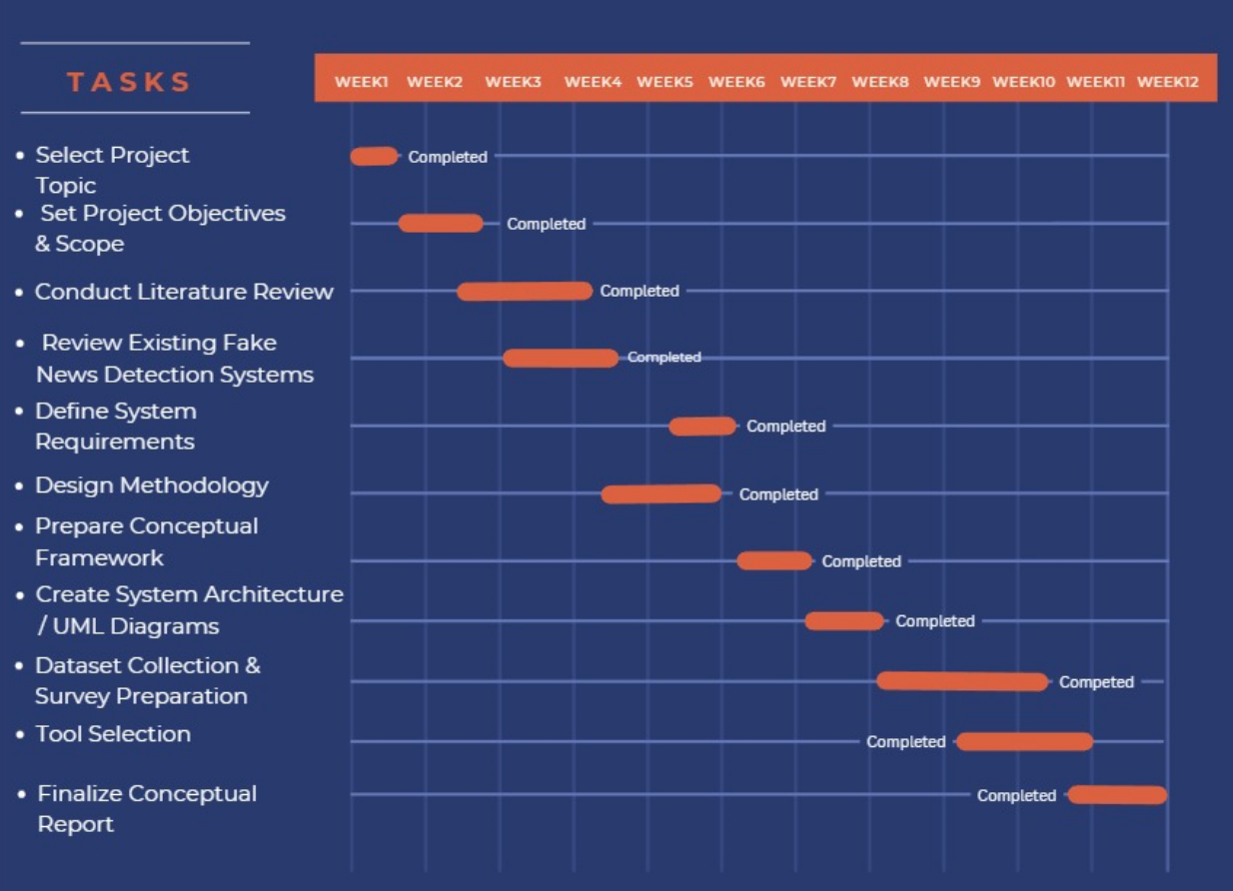

Risk Analysis
SN | Risk Description | Impact | Mitigation Strategy
1 | Delay in training or integrating NLP model due to limited dataset availability. | High | Use pre-trained NLP models initially (e.g., BERT) and fine-tune later when more data is collected.
2 | Incompatibility between Spring Boot (Java) and NLP microservice (Python). | High | Implement RESTful API-based communication and containerize both services using Docker for smoother integration.
3 | Performance issues on low-end devices when running Flutter app. | Medium | Optimize Flutter UI, use lazy loading for large data, and test across multiple device configurations.
4 | Data privacy and security risks when handling user study data. | Medium | Encrypt stored data, apply Firebase Authentication, and follow GDPR/FERPA compliance guidelines.

Workflow Diagram
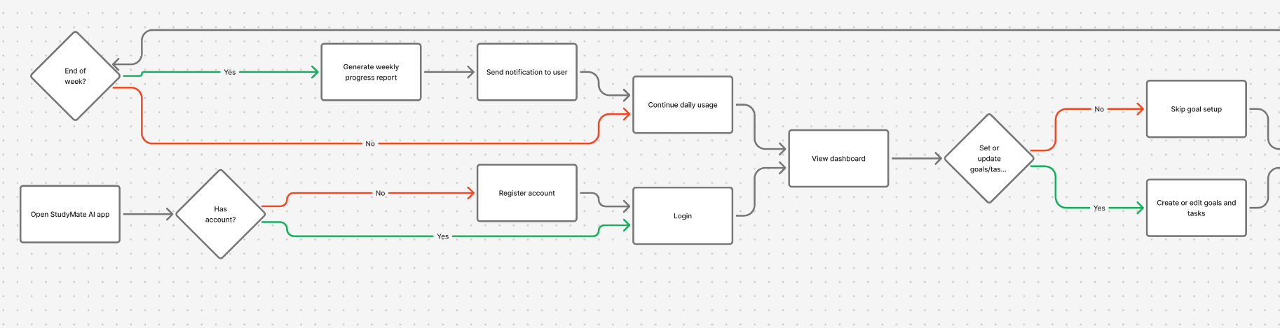
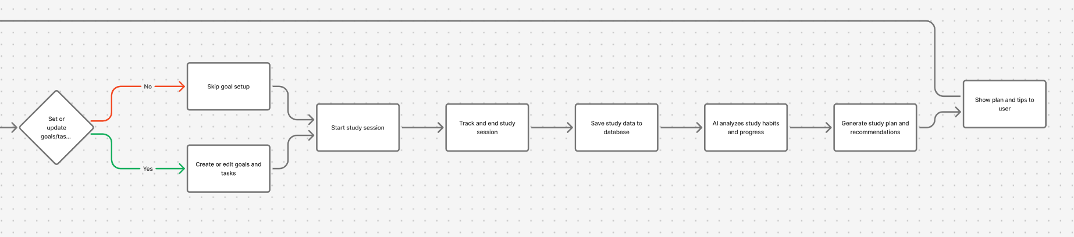

Summary of LR
As presented in the literature review, artificial intelligence has contributed greatly to the current learning systems through personalisation, adaptive scheduling, and automatic assessment. Research indicates that AI-powered tools can evaluate the behaviour of a learner, trace the areas of his/her weaknesses, and provide personal learning assistance, which is the very essence of the StudyMate AI. The studies of learning analytics and knowledge tracing show that it is possible to track and predict patterns of student performance, which is relevant to systems that offer dynamic recommendations and standard feedback.
Natural Language Processing (NLP) has become a powerful base of education tools, particularly those based on transformer-based models that are able to summarise text, comprehend context and create quiz questions automatically. The artificial intelligence quiz generator of StudyMate is based on these methods. Research in Automatic Question Generation (AQG) indicates that neural methods are superior in comparison to traditional rule-based methods, and they are capable of generation of more accurate and meaningful assessment items, in case of sufficient preprocessing and filtering.
Timetabling studies suggest that the Genetic Algorithms, heuristic and metaheuristic algorithms are useful in the development of flexible and adaptable study plans. Through these strategies, systems are enabled to remodel work in terms of performance, challenge and priority and this is what makes StudyMate to be designed as an adaptive study planner. Software architecture literature highlights the use of microservices as an appropriate model to tie Python-based AI models with Spring boot backends to scale, allow models to be modular and have models that are easier to update.
Lastly, the evaluation brings up such ethical issues as privacy and fairness, as well as responsible data treatment, which must be considered when developing AI-driven educational tools. All in all, in the reviewed studies, it can be concluded that the features and technological direction of StudyMate AI are viable and relevant.

Justification
The literature that has been reviewed is quite solid in the argument of the creation of StudyMate AI in the form of a useful and efficient tool that can help contemporary students. Studies always prove that old fashioned items used in studies like fixed planners and manual to-do lists are not enough since they cannot change with changes in the performance of students and make the learning process personal. Instead, AI-based systems have proven to increase the engagement, accuracy, and learning outcomes due to their use of provided guidance that is based on real-time data.
The effectiveness of NLP and transformer-based models is justified by the research that proved their usefulness in generating quality questions and extracting important ideas in the raw text. This justifies the use of a tailored NLP model on the generation of quizzes at StudyMate. On the same note, the existing evidence of adaptive scheduling and Genetic Algorithms shows that the two methods are capable of effectively tackling dynamic planning problems and thus they are applicable in the development of flexible study timetables to address the weaknesses of students.
Additionally, the microservice architecture is supported by studies discussing its benefits in the context of machine learning integration and scaling as well as the ability to update models continuously. This is in line with the system requirement to attach a Python-based NLP model to a Spring boot backend. The literature contains ethical guidelines that also warrant the consideration of secure data-handling practices, which means that StudyMate will not violate privacy and user trust.
Overall, the literature is quite convincing in the fact that the architecture, algorithms, and features of StudyMate AI are highly viable and are based on the best practices and the existing tendencies in AI-based education.
Chapter 4 – Primary Research
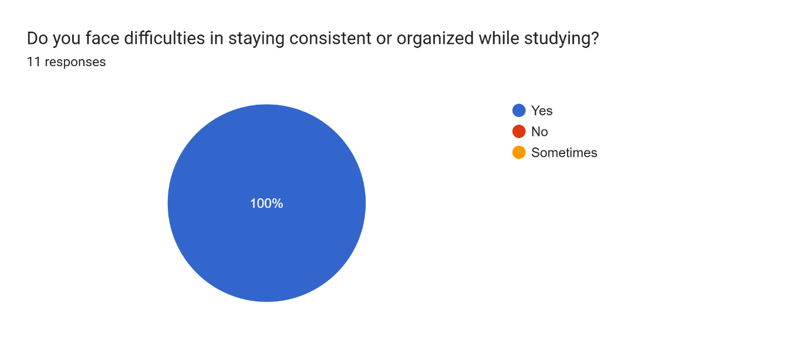
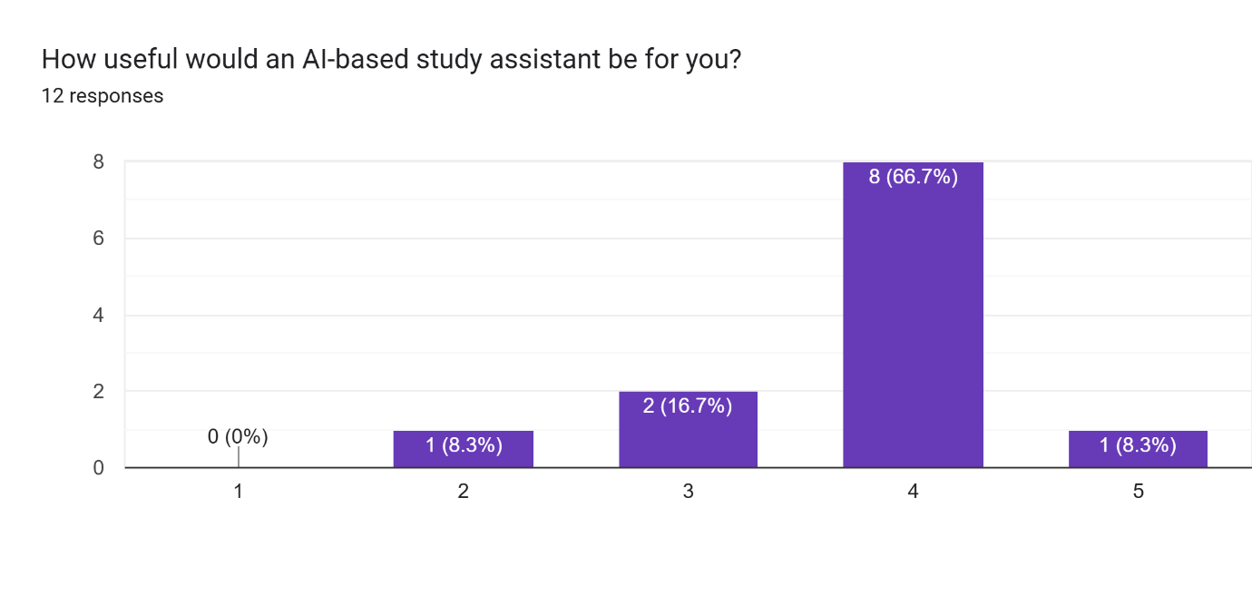
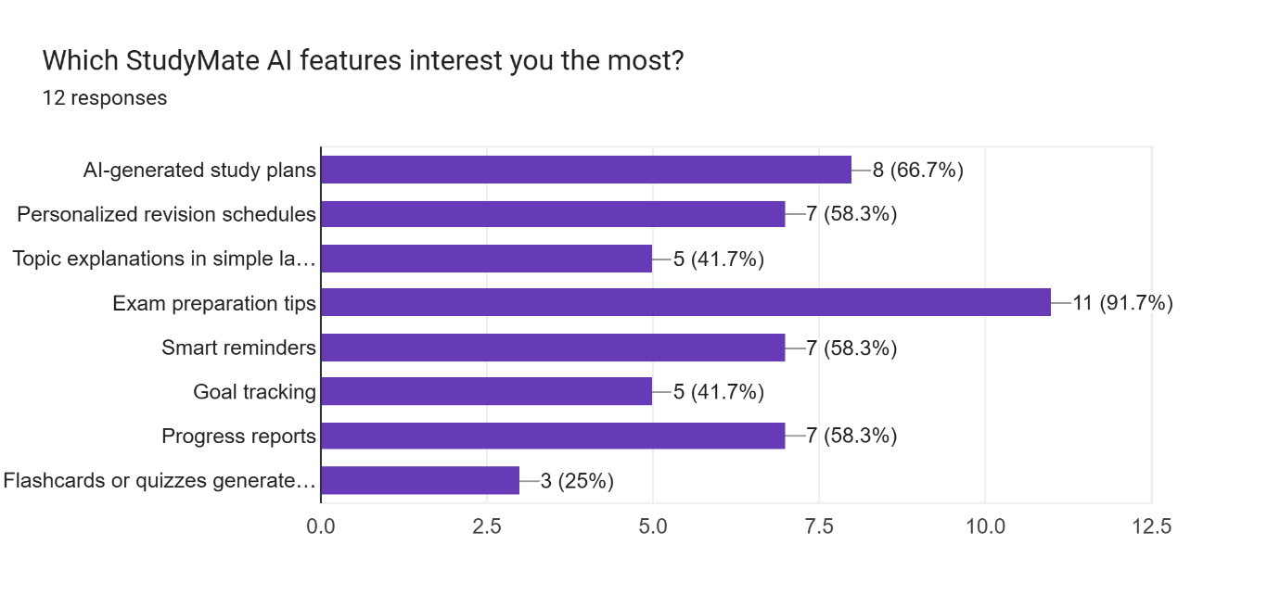
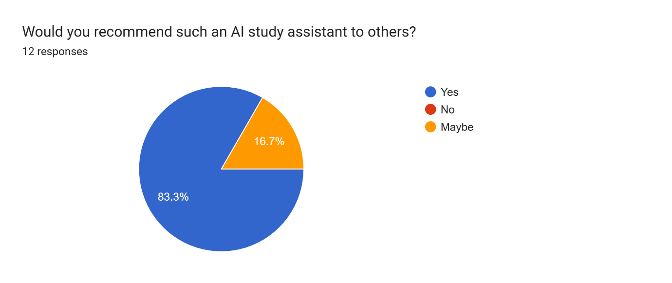

Chapter 5-
Functional Requirements
FR No. | Functional Requirement | Description
FR-01 | User Registration & Login | Users can register (Admin only logs in) and securely access the system.
FR-02 | Upload Notes | Users can upload text, PDFs, or study materials.
FR-03 | NLP Processing | System analyses uploaded notes and extracts key points, summaries, and important topics.
FR-04 | Personalized Quiz Generation | System generates quiz questions based on uploaded notes and weak areas.
FR-05 | Study Plan Recommendation | System recommends personalized study plans based on user goals and performance.
FR-06 | Progress Tracking | Tracks user progress, quiz performance, and study habits.
FR-07 | Notifications & Reminders | Sends reminders for study schedules, deadlines, and tasks.
FR-08 | Admin Dashboard | Admin monitors users, system performance, and manages reports.

Non-Functional Requirement
NFR No. | Non-Functional Requirement | Description
NFR-01 | Performance | System should respond within 3 seconds.
NFR-02 | Security | All user data must be encrypted and securely stored.
NFR-03 | Usability | UI must be simple, intuitive, and easy for students.
NFR-04 | Scalability | System must support growth in users and study materials.
NFR-05 | Reliability | App should maintain 99% uptime with consistent functionality.
NFR-06 | Maintainability | System should be easy to update using microservices structure.
NFR-07 | Compatibility | App must run on both Android and iOS devices.

Hardware requirements
- Mobile device capable of running Flutter apps (Android or iOS).
- Development laptop with minimum 8 GB RAM and Intel i5 or equivalent.
- Server machine with at least 8 GB RAM, Quad-core CPU, and SSD storage.

Software Requirements
- Frontend: Flutter
- Backend: Spring Boot (Microservices)
- NLP Processing: spaCy / Stanford NLP / NLTK
- Database: PostgreSQL
- IDE: Visual Studio Code (for Flutter), IntelliJ IDEA (for Spring Boot)
- Version Control: Git + GitHub
- Operating System: Windows 10/11

References
Colorni, A., Dorigo, M. & Maniezzo, V. (1990) ‘Genetic algorithms and timetabling’, Journal of the Operational Research Society, 41(4), pp. 297–306.
Cui, Y. et al. (2019) ‘Machine learning approaches for student performance prediction’, IEEE Access, 7, pp. 8129–8141.
Du, X. & Cardie, C. (2018) ‘Harvesting and generating question-answer pairs from Wikipedia’, Proceedings of NAACL, pp. 190–201.
Fan, Y., Yan, Z. & Sun, B. (2022) ‘Neural approaches to automatic question generation’, IEEE Transactions on Learning Technologies, 15(1), pp. 68–82.
Floridi, L. & Cowls, J. (2019) ‘A unified framework of five principles for AI ethics’, Minds and Machines, 29(2), pp. 1–17.
Google. (2022) Flutter Documentation.
Holmes, W., Bialik, M. & Fadel, C. (2019) Artificial Intelligence in Education: Promises and Implications for Teaching and Learning. Center for Curriculum Redesign.
Ibrahim, R., Ng, A. & Chuah, K. (2018) ‘Genetic Algorithm for adaptive academic scheduling’, International Journal of Intelligent Systems and Applications, 10(5), pp. 15–24.
Kazanavičius, E., Jusas, V. & Butleris, R. (2021) ‘Microservice architecture for machine learning systems’, Information Technology and Control, 50(3), pp. 357–368.
Kim, Y. & Ahn, H. (2020) ‘Adaptive learning systems using reinforcement learning’, Journal of Educational Technology, 37(2), pp. 33–47.
Kim, Y.J. et al. (2021) ‘EdNet: A large-scale hierarchical dataset for AI education research’, Scientific Data, 8(1), pp. 1–12.
Kulik, J. (2016) ‘Enhancing learning with intelligent tutoring systems’, Educational Psychologist, 51(3–4), pp. 246–257.
Luckin, R. et al. (2016) Intelligence Unleashed: An Argument for AI in Education. Pearson.
Nallapati, R. et al. (2016) ‘Abstractive text summarization using sequence-to-sequence RNNs’, CoNLL Proceedings, pp. 280–290.
Papamitsiou, Z. & Economides, A. (2014) ‘Learning analytics and educational data mining’, Educational Technology & Society, 17(4), pp. 49–64.
Piech, C. et al. (2015) ‘Deep knowledge tracing’, NIPS Proceedings, pp. 505–513.
Rahimi, S. (2020) ‘Automatic MCQ generation using transformer models’, International Journal of Artificial Intelligence in Education, 30(4), pp. 678–695.
Romero, C. & Ventura, S. (2020) ‘Educational data mining: A review’, Computers & Education, 147, 103–122.
Sun, Y. & Lam, C. (2021) ‘Review of adaptive learning technologies’, Computers in Human Behavior Reports, 3, 100–115.
Vaswani, A. et al. (2017) ‘Attention is all you need’, NeurIPS, pp. 5998–6008.
Wang, H. & Zhao, L. (2022) ‘Personalised feedback generation in intelligent tutors’, Journal of Computer Assisted Learning, 38(2), pp. 398–414.
Wei, X. (2020) ‘Optimisation techniques in educational scheduling’, International Journal of Computational Intelligence Systems, 13(6), pp. 662–673.
Zhang, Y. & Bansal, M. (2019) ‘Addressing semantic drift in question generation’, ACL, pp. 243–253.
Ardana, N. B. H. & Sari, A. S. A. (2024) ‘Development of adaptive lecture scheduling system using genetic algorithm (case study: Ahmad Dahlan Institute of Technology and Business)’, Journal of Computer Science Advancements, pp. 200–212.
Dagoc, R. P. & Orlanda, R. M. (2024) ‘Pupils’ study habits and academic performance’, International Journal of Multidisciplinary Research and Analysis, 7(3).
Gupta, T., Kumar, A. R. & Singh, S. (2024) ‘Adaptive learning systems: Harnessing AI to personalize educational outcomes’, Journal for Research in Applied Science & Engineering Technology.
Hariyanto, K. F. D. & Mahdi, R. (2025) ‘Artificial intelligence in adaptive education: A systematic review of techniques for personalized learning’, Discover Education, 4, p. 458.
Poudel, T. N. (2023) ‘Relationship between study habits and achievements of grade ten students in Nepal’, Journal of Advanced Academic Research, 3(3).

